**Assignment Front Cover Sheet**

**TITLE PAGE**

**Programme of Study: Foundation Degree in Applied Computing**

**ASSIGNMENT**

**NAME OF STUDENT: YEAR OF STUDY 2**

**College Email Address:**

**Unit code: LP20552A1 Unit Title Mobile Technologies**

**Unit Tutor Danielle Vass danielle.vass@bathcollege.ac.uk**

**ASSIGNMENT TITLE:**

**LP20539A1: App Development**

**WORD COUNT DATE SUBMITTED**

**(May not exceed +/- 10% of limit) (Late submissions may be penalised)**

**CHEATING AND PLAGIARISM DECLARATION**

**I confirm the following**

*I have read and understood the following sources that explain cheating and plagiarism;*

*the University of Bath website at* <http://www.bath.ac.uk/library/help/infoguides/plagiarism.html>

*and my programme handbook*

*To the best of my knowledge, my work does not contain plagiarised material.*

**SIGNATURE:**

Ensure that you have completed your work as specified by the deadline date and time (**Thursdays 4pm**)

You must submit one electronic copy of your work to the relevant location as detailed in the assignment brief and/or the Regulations for Submitting Assignments document.

You must keep a copy (electronic and paper) of this assignment for your own records.

|  |  |  |  |  |  |  |
| --- | --- | --- | --- | --- | --- | --- |
| bath college MONO copy | | Assessment feedback form Students must attach this form and the assessment brief to work submitted for assessment | | | | UoB_logo-blu-xs |
| Hand out date: | | *(as per assessment plan)* | Hand in date: | | | *(as per assessment plan)* |
| Assessor: | | Danielle Vass | Date received: | | |  |
| Assessor’s comments Task 1: Presentation about the past, present and future of mobile apps (20%)  Task 2: Mobile app (70%  Task 3: Demonstrate of the app (10%) | | | | | | |
| Percentage mark awarded |  | | | Contribution to Unit Marks | | 60% |
| Unit Outcomes | * Analyse and recommend an appropriate mobile solution for the workplace. * Demonstrate an understanding of a variety of mobile technologies (e.g. Mobile-device based languages, operating systems, internet browsers and environments). * Produce a mobile application for a given specification. * Research current developments in emerging mobile device techniques. | | | | | |
| Assessor’s signature |  | | | | Date |  |
| Moderator’s signature |  | | | | Date |  |

# Aims

This assignment aims to provide evidence for the learning outcomes of the unit. (See above).

It will demonstrate your ability to do the following:

* Use GUI design and visual programming skills in a given language.
* Show good problem solving skills, Time management and Planning and prioritisation of tasks.
* Prepare high quality reports and documentation to support applications.
* Present information appropriately.
* Perform user demonstrations and prepare questionnaires to aid critical evaluation of products.

# Scenario

You are tasked by a specialist subject teacher to create a **questionnaire Android app**.

The app will test how much information students already know using short questions. For example, a geography teacher might want to establish if students know flags, or capital cities for countries in the World. Students will be given a final score which can be used by the teacher to evaluate their prior knowledge.

You must also come up with at least one additional feature of your own choice e.g. more questions, or question topics.

To achieve the highest marks possible your app should also connect to an API online to retrieve questions. The method of which must be discussed prior to the app submission.

Finally, you must demonstrate a good HCI and incorporate some Material Design aspects into your app.

Your app is required to run on Android 5.0 (SDK 21) and above. It is not necessary to have a real Android device yourself, as Android Studio will provide an emulator to use.

Tasks

1. Create a presentation (with detailed notes) about past, present and future developments in mobile technologies. You are not going to do present this task, it will be submitted electronically. So the presentation should be written to be meaningful to the assessor. The presentation should be approximately 15 minutes of material.
2. A working mobile application that meets the brief, plus fully commented code. (60%)
3. A demonstration of the app 1-1 where students defend their work

# SubMISSION

You should submit via a GitHub repository:

* Folder with all source code for your Android app
* Folder for presentation in a .ptx format (not .pptx)

# Grading Criteria

|  |  |  |  |
| --- | --- | --- | --- |
| **Element** | **Wt.** | **Criteria** | **Mark** |
| Task 1: Presentation about the past, present and future of mobile apps | 20% | Standard of English | 0 – 5 |
| Multiple Operating Systems mentioned (Android, iOS, Blackberry, Windows Mobile) | 0 – 8 |
| Future tech | 0 – 7 |
| Task 2: Mobile app | 70% | Profile or About Interface | 0-5 |
| Introduction Interface | 0-5 |
| Questions Interface | 0-10 |
| High Scores Interface | 0-10 |
| Persistant Storage of High Scores | 0-5 |
| Questions retrieved from Internet API | 0-15 |
| Bonus feature of your choice | 0-15 |
| HCI and material design | 0-5 |
| Task 3: Demonstrate of the app | 10% | Defence and justification of how app works | 0-10 |

|  |
| --- |
| **Reflections on past, present and future of mobile technology** Nicholas A. Esposito |

UoB_logo-blu-xs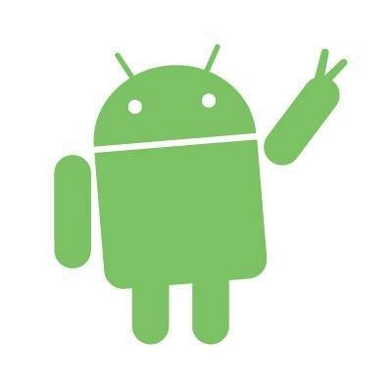

|  |  |
| --- | --- |
| **LP20539A1** | Mobile Technologies |

Table of Contents

[Abstract: 6](#_Toc436916921)

[Introduction: 7](#_Toc436916922)

[The path that brought us to the current state of art: 7](#_Toc436916923)

[Past of mobile: 8](#_Toc436916924)

[Smartphones: 8](#_Toc436916925)

[2007, Apple reinvents the phone: 9](#_Toc436916926)

[Present situation: 11](#_Toc436916927)

[The future of mobile technology: 12](#_Toc436916928)

[Hardware: 12](#_Toc436916929)

[Software: 12](#_Toc436916930)

[Conclusion: 12](#_Toc436916931)

[References: 13](#_Toc436916932)

[APPENDIX A, android versions timeline and features: 14](#_Toc436916933)

[APPENDIX B, iOS versions timeline and features: 17](#_Toc436916934)

# Abstract:

This report has briefly analyzed the past, present and future of mobile technology related to mobile phones.

The way how our perception of mobile phones have rapidly changed within 40 years has been presented and reflections been made.

The report concludes then with a reflection of how mobile technology is not just changing lives of its user but also empowering developers to shape the future.

# Introduction:

The following report will present consideration and reflections on the past, current and future state of mobile technologies.

The term mobile technology refers to any device that is portable, allowing users to carry devices and to perform with them a wide variety of “tasks”.

Within the years’ mobile technology has seen a quick growth with most of standard mobile devices having now a vast array of functionalities such as:

* Cellular phone
* GPS
* Web browser
* Instant messenger system
* Video gaming system

More and more functionalities are added on a daily basis, with the help of a vast population of developers empowering users with a continuous stream of new and exciting ideas.

This report will not talk about mobile technologies in general but will focus solely on the evolution of Mobile phones.

# The path that brought us to the current state of art:

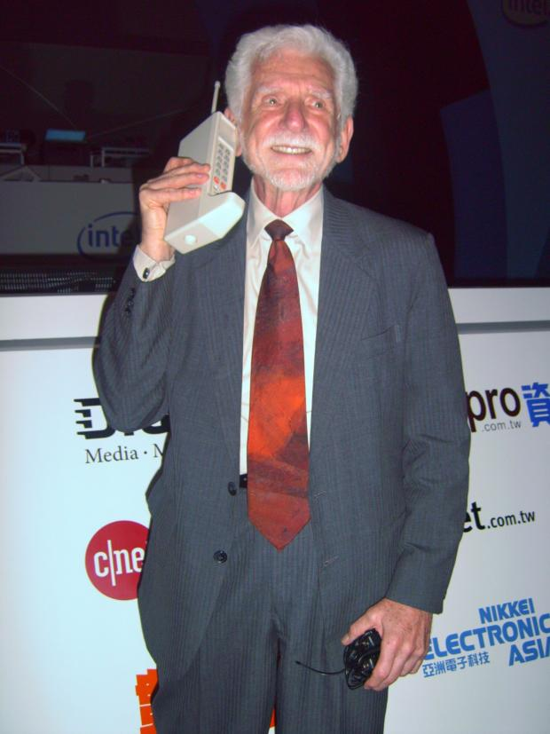

**1973**, the world first mobile call is made on the 3rd of April 1973 by Martin Cooper, a senior engineer at Motorola;

Martin called a telecommunication company and informed them he was speaking via a mobile phone.

 The phone Cooper used, weighed a staggering 1.1kg and measured in at 228.6x127x44.4mm. With this prototype device, you got 30 minutes of talk-time and it took around 10 hours to charge

(Know Your Mobile, 2015)

There is no doubt things have changed since Martin Cooper’s first mobile call, our devices have become more and more smaller and functional, to the extent that today a phone call might be the last think we would think about doing with our mobile phones.

*Martin Cooper with the Motorola DynaTAC 8000X*

## Past of mobile:

When the first mobile phone, the Motorola DynaTAC 8000X in 1983 gets commercialized, the mobile handset was not designed with consumers in mind, it was expensive, bulky and with limited functions, only wealthy or business-mans would buy (or afford to buy) one of those devices.

It is only on the late 90’s that consumers start to take serious interest in mobile devices with prices going down and design and portability drastically improving, few examples are represented in the following table.

|  |  |
| --- | --- |
| **1997 Nokia 6110** |  |
| **1997 Motorola StarTAC** |  |
| **1999 Blackberry 850** |  |

It’s not a case that those three devices have been picked as an example, in fact until approximately 2010 the producer of those handsets, Motorola, Nokia and Blackberry would be the undiscussed leader of the mobile industry;

In particular Nokia and Blackberry would lead the market with a new category of mobile phones, the **smartphones.**

### Smartphones:

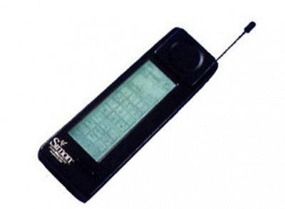The definition of a smartphone according to the Oxford dictionary is: “A [mobile phone](http://www.oxforddictionaries.com/us/definition/american_english/mobile-phone#mobile-phone__3) that performs many of the [functions](http://www.oxforddictionaries.com/us/definition/american_english/function#function__7) of a computer, typically having a [touchscreen](http://www.oxforddictionaries.com/us/definition/american_english/touchscreen#touchscreen__2) [interface](http://www.oxforddictionaries.com/us/definition/american_english/interface#interface__6), Internet [access](http://www.oxforddictionaries.com/us/definition/american_english/access#access__8), and an [operating system](http://www.oxforddictionaries.com/us/definition/american_english/operating-system#operating-system__2) capable of running [downloaded](http://www.oxforddictionaries.com/us/definition/american_english/download#download__2) [applications](http://www.oxforddictionaries.com/us/definition/american_english/application#application__12).”

(Oxforddictionaries.com, 2015)

The first smartphone ever produced is the IBM Simon Personal Communicator, it was commercialized in 1994 and equipped with a touchscreen, email and fax capability and a few apps too!

The IBM Simon though was not a success and lasted in the market for just 6 months. (Aamoth, 2014)

*The IBM Simon, first commercialized smartphone*

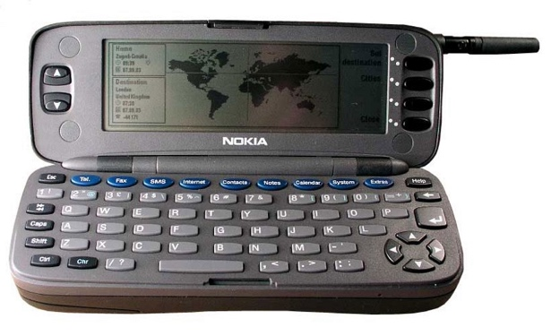The first smartphone to encounter success in the market was the Nokia 9000 Communicator.

*The Nokia 9000*

*communicator*

The Nokia 9000 Communicator was released on 1996 with the operating system GEOS that would then evolve into **Symbian OS** in 1998.

From 1998 to 2011 Symbian OS along with **BES** (Blackberry OS) would rule the smartphone market.

### 2007, Apple reinvents the phone:

The 9th of January 2007 mobile phone technology gets revolutionized with the introduction of what Steve jobs during his keynote describes as “a wide screen iPod with touch controls, a revolutionary mobile phone and a breakthrough internet communication device”, the **iPhone**.

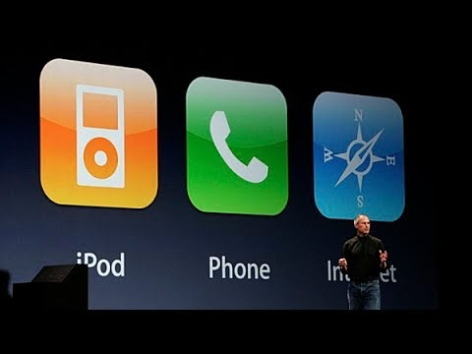

*Steve Jobs presents the first iPhone*

Since its commercialization, the iPhone has changed the mobile technology making smartphones and touchscreens the new market trend.

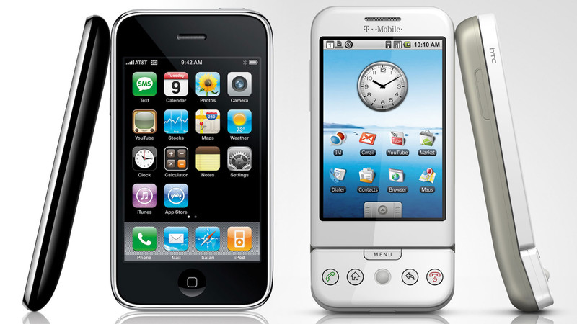

*The first iPhone and the first Android device*

In November 2007 on the footprints of Apple’s **iOS,** Google presents **Android,** an open source mobile operating system free to use from anyone in the market.

The two operating system gets adopted quickly from the public whilst RIM (Blackberry) and Nokia’s Symbian market share suddenly experience a massive user drop.

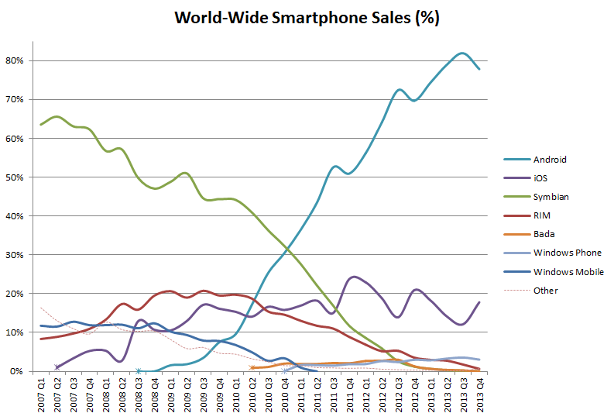

As visible from the graph, 2010 is the critical year for Symbian and Rim; Symbian would then exit the mobile market on 2013 with Nokia adopting Windows mobile and Blackberry, although still using BES on few devices, adopting Android.

## Present situation:

Is now 2015 and the mobile market sees Android and iOS leader in the industry followed by a smaller percentage of people using Windows mobile or other minor OS.

|  |  |  |  |  |  |
| --- | --- | --- | --- | --- | --- |
| **Period** | **Android** | **iOS** | **Windows Phone** | **BlackBerry OS** | **Others** |
| **2015Q2** | 82.8% | 13.9% | 2.6% | 0.3% | 0.4% |
| **2014Q2** | 84.8% | 11.6% | 2.5% | 0.5% | 0.7% |
| **2013Q2** | 79.8% | 12.9% | 3.4% | 2.8% | 1.2% |
| **2012Q2** | 69.3% | 16.6% | 3.1% | 4.9% | 6.1% |

(www.idc.com, 2015)

The wide spread of smartphone with powerful OS has drastically changed the concept of mobile phones from devices used mostly for sending and receiving phone calls and short messages to tools empowering our everyday life.

Today we use our phone to:

* Take pictures and video and share them
* Use social media
* Surf the internet
* Listen to the music
* Watch movies, videos, TV
* Get directions

And much much more.

The empowerment coming from our smartphone today is also due to the vast community of mobile developers that with their apps every day find new and exciting way to use our smartphones differently.

## The future of mobile technology:

As proved from the last 40 years mobile technology is a field in constant progression, hardware and software advancement achieved from 1973 are unbelievable and surely the future has more to offer.

### Hardware:

Phones are today part of everybody’s everyday life, an everyday life that includes water, sand, phone drops and lack of electricity plug.

The future of hardware will probably see the raise of new, stronger materials that will make phones more resistant to drops or any other accidents.

Phones will probably all be water and sand resistant (water resistant models are already available on the market).

The biggest efforts though on hardware level will probably be made on finding new ways to increase battery life.

Currently prototypes of batteries that fully charge in one minute are being tested *(Engadget, 2015)* along with an iPhone prototype that contains a battery working with hydrogen that made the device keep the charge for a whole week *(Goldman, 2015).*

### Software:

The biggest advancements on mobile phones will probably be at a software level, mobile OS are improving and will keep on improve on stability, accessibility and performance.

Probably though software wise it won’t be the OS being the main character when talking about the future of software but the mobile apps developed that will change the way phones are used.

Uber, Deliveroo, Spotify are app that have revolutionized the way phones are used and changed lifestyles in the present time, the future will probably see driverless car managed by phone apps, the death of cash payments and paper tickets fully substituted by their digital version; phones will become a constant part of our life more than they are now.

# Conclusion:

Considering the past and present of the future is clear how fast and dynamic this industry is and it’s easy to predict how exciting the future will be.

Phones have been replacing our iPod, alarm clock, camera, calculator and many other things we used to carry with us giving us more and more way to connect with each other and the world around us.

The most exciting thing about mobile technology though is probably the fact that not only empower users but also gives the power to those writing software for those devices to shape the future of the world.

# References:

**Strategicgrowthconcepts.com, 2015**. *Mobile Technology Facts*. [online] Available from: http://www.strategicgrowthconcepts.com/growth/increase-productivity--profitability/mobile-technology-facts.html [Accessed 2 Dec. 2015].

**Know Your Mobile, 2015**. *The History of Mobile Phones From 1973 To 2008: The Handsets That Made It ALL Happen*. [online] Available from: http://www.knowyourmobile.com/nokia/nokia-3310/19848/history-mobile-phones-1973-2008-handsets-made-it-all-happen [Accessed 2 Dec. 2015].

**Oxforddictionaries.com, 2015**. *smartphone: definition of smartphone in Oxford dictionary (American English) (US)*. [online] Available from: http://www.oxforddictionaries.com/us/definition/american\_english/smartphone [Accessed 2 Dec. 2015].

**Aamoth, D., 2014**. *First Smartphone Turns 20: Fun Facts About Simon*. [online] TIME.com. Available from: http://time.com/3137005/first-smartphone-ibm-simon/ [Accessed 2 Dec. 2015].

**www.idc.com, 2015**. *IDC: Smartphone OS Market Share*. [online] Available from: http://www.idc.com/prodserv/smartphone-os-market-share.jsp [Accessed 3 Dec. 2015].

**Engadget, 2015**. *Stanford's aluminum battery fully charges in just one minute*. [online] Available from: http://www.engadget.com/2015/04/06/stanfords-battery-charges-in-one-minute/ [Accessed 3 Dec. 2015].

**Goldman, D., 2015**. *One week battery life on an iPhone 6? It's possible*. [online] CNNMoney. Available from: http://money.cnn.com/2015/08/28/technology/battery-life-iphone-6/ [Accessed 3 Dec. 2015].

# APPENDIX A, android versions timeline and features:

**2008: Android 1.0 and 1.1**

*main features:*

* Android market to buy and sell apps
* Android browser to surf the web
* Google Maps connected to Wi-Fi and gps
* Sync for contacts, emails and calendar with google account

**2009: Android 1.5 Cupcake**

*main features:*

* Virtual keyboard
* Widgets
* Video recording and YouTube sharing capabilities
* Copy and paste function

**2009: Android 1.6 Donut**

*main features:*

* Universal search
* Support for multiple screen resolutions
* Google maps turn by turn navigation

**2009: Android 2.0 and 2.1 Eclair**

*main features:*

* Microsoft Exchange support
* Support for multiple Google accounts
* Improved camera settings
* MultiTouch support

**2010: Android 2.2 Froyo**

*main features:*

* Flash Player
* Settings synced into google account
* Hot spot capability

**2010: Android 2.3 Gingerbread**

*main features:*

* NFC capabilities
* Support for front facing camera
* Download manager

**2011: Android 3.0 and 3.1 Honeycomb**

*main features:*

* Tablet support
* U.I. design refinements
* Tabbed navigation

**2011: Android 4.0 Ice cream sandwich**

*main features:*

* Face recognition to unlock phone
* Live video effects
* Network traffic monitor

**2012: Android 4.1,4.2 and 4.3 Jelly Bean**

*main features:*

* Google now
* U.I. refinements
* Project butter

**2013: Android 4.4 KitKat**

*main features:*

* U.I. refinements
* Full screen apps

**2014: Android 5.0 and 5.1 Lollipop**

*main features:*

* Material design introduction
* Android TV Support
* Android at work
* Dual sim support

**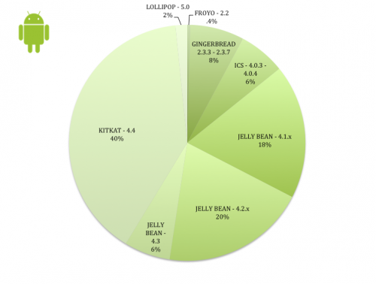2016 Android 6.0 Marshmallow**

*main features:*

* Fingerprint scanner
* Android Pay

Versions running on devices as of January 2015

# APPENDIX B, iOS versions timeline and features:

**2007: iOS1**

*main features:*

* Touch screen interface
* iPod features
* Google Maps
* Visual voicemail
* iTunes Sync

**2008: iOS2**

*main features:*

* App Store
* Microsoft exchange support

**2009: iOS3**

*main features:*

* Cut, Copy and paste
* Spotlight search
* Tablet support
* Voice control

**2010: iOS4**

*main features:*

* Multitasking
* FaceTime
* Home screen folders
* Retina display support

**2011: iOS5**

*main features:*

* Siri
* iMessage
* No PC required to activate iPhone
* iTunes Wi-Fi sync
* over the air updates
* iCloud

**2012: iOS6**

*main features:*

* Apple Maps
* Notification center
* Facebook integration
* Passbook
* FaceTime over cellular

**2013: iOS7**

*main features:*

* UI redesigned from the ground up from skeuomorphism to flat design
* AirDrop
* Free iWork
* iTunes radio
* FaceTime audio
* Automatic updates
* TouchID

**2014: iOS8**

*main features:*

* Continuity
* iCloud Drive
* HomeKit
* HealthKit
* Family sharing

**2015: iOS9**

*main features:*

* News
* ApplePay
* 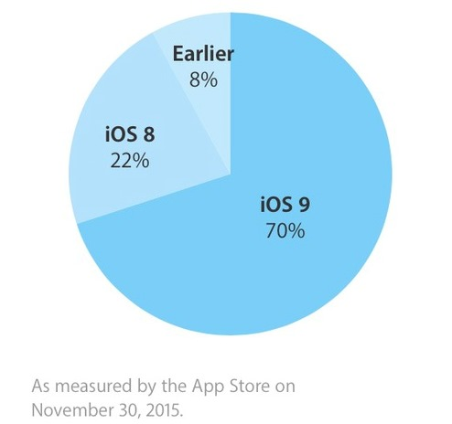SplitView
* Siri in context responses